Melbourne Chicken Rescue
Chicken Care Booklet

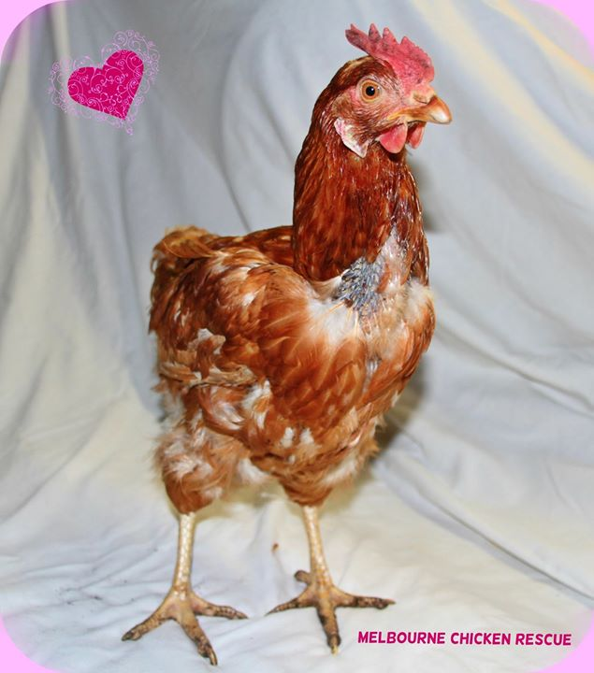

This booklet has been prepared by Melbourne Chicken Rescue.
© Melbourne Chicken Rescue 2014

TABLE OF CONTENTS

TABLE OF CONTENTS 2
YOUR ADOPTED GIRLS 3
FOOD 4
WATER 8
EXTRAS 8
INTRODUCING NEW CHICKENS TO AN EXISTING FLOCK 9
HOUSING 9
BEDDING 12
LICE AND WORMING TREATMENT 12
VACCINATIONS 16
OTHER ANIMALS WITH CHICKENS 16
ILLNESS 16
BEAKS 22
MOULTING 22
BROODING 24
WHAT YOU CAN DO WITH THEIR EGGS 24
FIRST AID AND FIRST AID KIT 24
WHEN CHICKENS GET WET 25
WHEN CHICKENS GET HOT 25
TRANSPORTING CHICKENS 25
THE MAIN ISSUES FACED WHEN PROVIDING A HOME FOR CHICKENS 25
VETS 27
OTHER RESOURCES 28
YOUR MELBOURNE CHICKEN RESCUE TEAM 29
REFERENCES 29

The information contained in this booklet is by no means exhaustive and we strongly advise you undertake continual research to educate yourself on how to best care for chickens. This booklet forms a guide only.

YOUR ADOPTED GIRLS
Thank you for choosing to adopt ex-layer hens. They have up until this point, lived their entire lives in a cage or barn, having never seen the outside world, to feel the sun, the grass or the breeze. They never got to scratch around in the dirt looking for bugs, or get down and dirty in a dust bathing frenzy. They never got to spread their wings in bliss soaking up the sun. They just never got to be as a chicken should be.
Your girls have had a health check by us for the following:
- their face – to make sure they had no lumps on their face, no runny eyes or nose and no chest infections
- nails - to make sure their nails weren’t too long and to trim them if necessary
- feet – to make sure there are no issues like lumps/sores
- cloaca - we check to make sure their cloaca is intact and that there are no other obvious issues
- Lice/mites – we have thoroughly checked their bodies for lice/mites infestation
- and to check their general body condition.
We have sprayed all the girls with an avian lice spray as they always have some lice/eggs when coming from farms and they will be due for another spray in few weeks to make sure they are free of lice. If you use the Avian Liquidator Spray there is no concern with using it in a shorter timeframe than the suggested treatment of every 6 weeks, we confirmed this with the Bird Vet at Burwood. Follow the instructions on whatever product you buy.
We have also given your girls a calcium injection (0.3ml of calcium gluconate) to help them recover from the drain of laying so many eggs. Many chickens suffer from poor bone strength due to being fed a poor diet and not seeing the sun when confined in these farms. Bone breakages are common in the sheds.
Your girls will need to be treated for worms as you would do for their first round of treatment and then as per normal on a regular basis. Follow instructions on whatever product you buy.
To help them gain full health please provide them with:
- Extra calcium in powder or liquid injectable form (you will need to see your vet for the injectable type)
- Vitamins such as Soluvet which comes in a liquid form
- Good quality vegetarian grains and pellets
- Cracked maize is a nice fatty food if any of the girls are underweight and need to put weight on fast
- Lots of fresh vegetables/fruit such as corn, chickory, kale, silverbeet, spinach, cauliflower, grapes, watermelon
- Shell grit – oyster shells are the best form as they are easier for their bodies to absorb.
As they have come from a temperature controlled environment they will need lots of cosy and warm straw bedding. Please keep them away from cold draughts and make sure their bedding is dry.
We strongly recommend that you have your girls checked over by your local vet to ensure they are in good health.
You will notice that the girls may be in a bit of a straggly condition, however, with lots of love, attention, comfortable living quarters and good food, they will quickly return to how they should look, fully feathered, with a nice bright red comb and wattle, colour in their face and colour returning to their legs. They are often very pale due to never having seen the sun and therefore not getting enough vitamin D. They had been fed the very basic of feed when kept on the farm and the strain on their bodies from continuously laying at an unnatural rate whilst on an inadequate diet and most likely riddled with lice and mites, really taxes their little bodies.

The basic needs of a chicken
- Safety. They need a fox proof house to sleep in at night
- Warmth in the cold months, cool in the hot months
- Good quality food
- Fresh water cleaned regularly
- Clean house
- Attentiveness to their behaviour
- Willingness to take them to the vet at the first signs of illness

Things to keep away from your chickens
- Avocado - will kill them
- Styrofoam - they will peck at this and eat the little balls which obviously, is not good for them
- Glass - make sure your yard is free from glass so they don’t cut their feet
- Wire - as above so they don’t hurt themselves
- Mould - will kill chickens. Make sure all food such as seed and pellets are kept dry and sealed in a container/tub
- Lawn clippings from mowing the lawn - this is tainted with petrol and obviously not healthy for them to eat
- Bread – this can compact in their crop and cause blockages
- Ponds and pools – chickens can drown in small or large pools of water, ensure that if you have these that they are completely covered and secure
- Poisons such as snail pellets.

FOOD
We recommend feeding chickens vegetarian grains, pellets and mash and completely avoid products that contain animal products.
You can either feed the different foods in separate trays, or make a mix of grains and pellets at a ratio of 50/50. It is easiest to provide the vegetarian mash in a separate tray because it’s a finer food, you can add water to it as well, it just depends on what the girls prefer and time will tell you this.
The brands we recommend are:
- Peters Free Range Poultry mix (seed)
- Red Hen Free Range Layer (seed mix - green/red bag only is vegetarian)
- CopRice Lucky Layer pellets
- Country Heritage Free Range Vegetarian Layer Mash
Chickens graze all day and therefore must have access to food all day.
If you are going to have a number of chickens in your care, then place a number of food trays out for them, spread around so they can eat without worrying about being bullied by others. Same applies to water.
Place an additional small tray of shell grit for them to eat if they choose to do so. Grit contains calcium but also helps the chicken grind the food up in their gizzard. It is not unusual to see a chicken eat small shells and rocks too and many foods you buy for them will contain this. The best form of grit is oyster shell grit as it is absorbed by the chicken more readily than other forms.
You can leave a calcium carbonate powder purchased from a stock feed store, in a dish so the chickens can choose to freely eat it. Calcium is required for the production of egg shells and if soft shelled eggs are laid then there is an issue with adequate calcium in the diet.
Chicken food left out can attract rats and mice. This can easily be avoided by ensuring that the coop and feeding areas are cleared of food each night. Once settled in their new homes, hens can be taught to use a treadle feeder, which closes as they finish eating - preventing rats and mice from helping themselves to food. If you are interested, check out this link http://www.chooketeria.com/Welcome.html. It may take your chickens a few days to learn how to use it but is worth the investment.
We find that cat litter trays are suitable for using as food trays, they can also be used for water dishes.
On cold days you can try giving them a warm food like oats or porridge.
On hot days you can freeze vegetables in water.
Peters Free Range Poultry Mix
http://peterspureanimalfoods.com/products/poultry/food/free-range-poultry-mix.php
Peters Free Range Poultry Mix is formulated to meet the nutritional requirements of all breeds of adult home lay chickens, ducks, geese and turkeys. Made from a premium blend of whole and cracked grains, Peters Free Range Poultry Mix is free of artificial colours, flavours, growth hormones and antibiotics and contains no animal by-products. By consuming nutritious, healthy poultry food, laying birds will produce nutritious, healthy eggs ~ eggs that taste great and are good for you and your family.
Suitable for all breeds of chickens, ducks, geese and turkeys and may be introduced to poultry from 8 -10 weeks of age.
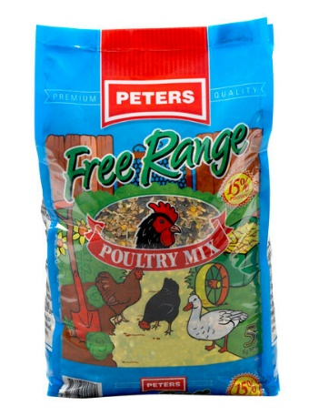
CopRice Lucky Layer
http://www.coprice.com.au/poultry-poultry/2012-07-18-09-58-51/lucky-layer
CopRice Lucky Layer is a perfectly balanced and complete pelleted feed providing all of your hen’s daily nutritional requirements. It uses the best ‘natural’ ingredients with added vitamins, minerals, and trace nutrients, including high quality vegetable proteins to supply essential amino acids, great for egg production and size.
CopRice Lucky Layer is a vegetarian feed using only cereal and vegetable protein sources to deliver high quality protein to the free range hen. CopRice Lucky Layer has no added hormones or antibiotics and contains an egg yolk pigmenter, derived from the marigold flower.
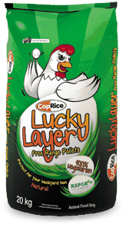
Red Hen Free Range Layer
Red Hen Free Range Layer is a high energy premium quality poultry breeder and layer food formulated to be fed to all classes of breeding and laying poultry.
This high specification diet is nutritionally balanced for essential nutrients necessary for high production, fertility and hatchability.
Linoleic acid is included in the diet at a minimum of 1.3% for enhanced egg size.
Red Hen Free Range Layer is a mixture of whole and rolled grains fortified with vitamins, minerals, and other essential nutrients and coated with vegetable oil and molasses.
Red Hen Free Range Layer is a medication and meat free diet.
Country Heritage Free Range Vegetarian Layer Mash
Country Heritage Organic Free Ranger Vegetarian Layer Mash is a complete feed formulated with a minimum of 18% protein and all the vitamins and minerals necessary for healthy hens and maximum egg production. Completely sourced from vegetables and Australian Organic Certified.

Storage of food

Keep chicken food such as seeds and pellets in watertight and secure storage, rubbish bins are quite useful as are storage containers, but the cheaper versions can be chewed through by mice and rats still. Sturdier containers will save you in the long run. These can be elevated off the floor too by using planks of wood or bricks.
Food must not get damp and mouldy. Mould is toxic to chickens and will kill them very quickly.

Giving vegies and fruit
Provide fresh vegetables and fruit to your chickens daily. When giving your girls fresh vegetables like spinach and kale, it is good to cut it up for them into smaller pieces. Unless it is wedged into something so that they can get leverage to tug at it, they can’t break it up into manageable pieces.
Do not feed chickens long bits of grass you have picked yourself, these get caught in their throat as they are too long. If you do give them handpicked grass, cut it up into pieces for them, no longer than a few cms long.
Initially they may not eat corn off the cob by themselves and you’ll need to cut it off for them.
Over time you’ll learn what they like to eat, and what they don’t like and the best way to give it to them.

WATER
Make sure water bowls/trays are cleaned regularly and contain fresh water, especially during summer. The dishes will need to be deep enough so the chickens can drink out of it properly. They use a scooping action and lift their heads up to the sky to drink, so any dishes need to accommodate this action.
Chickens will generally drink a lot of water, so it’s important to closely monitor the dishes.
In hot weather it is important to keep the trays of water out of the sun and to monitor the water supply even more closely.
We can’t stress enough how critical it is for chickens to have access to water at all times.

EXTRAS
You can help your girls along by giving them extra minerals and vitamins. Check out these websites for more information.
http://www.henrescue.org/#!chicken-supplies/c1lf2
http://planetpoultry.com.au/19-supplements

Soluvet
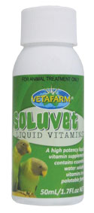

Soluvet Liquid is a liquid vitamin supplement with iodine for addition to water or soft foods and contains 13 essential vitamins to support birds on seed diets. It is readily absorbed in the gut and easily administered on soft food or in water. Soluvet Liquid should be used in conjunction with a trace mineral supplement, such as TRACEMIN, and a calcium supplement, CALCIVET or D NUTRICAL for birds on seed diets to ensure adequate nutrition.
DIRECTIONS FOR USE: Water: Add 2mL to 1L of drinking water or 2 drops per 50mL and mix well. Change water daily.
Food: Add 4 drops per 100g of soft food or hand rearing food and mix well.
You can purchase Soluvet from any pet supples store, here’s one of them http://www.vetnpetdirect.com.au/soluvet_liquid_vitamins#.VFGhg524a70

INTRODUCING NEW CHICKENS TO AN EXISTING FLOCK

Fighting (Establishing the pecking order)
When bringing new chickens into your home and you already have an existing flock of chickens, it is important to be there with them when they are introduced to each other so you can monitor any fighting and intervene if necessary.
When integrating there may be quite a bit of fighting, known as the pecking order, this will settle down until the hierarchy is re-established, and may take a few days. This can be quite un-nerving to watch, and if you feel the fighting is getting too aggressive then you can separate them.
There is plenty of information on the internet about chicken behaviour and the pecking order, here’s one link to help you get started: http://www.bhwt.org.uk/cms/merging-and-establishing-a-new-flock/

Separate enclosures/housing
It is always handy to have another separate area for when you get new chickens, as this can be used to quarantine them for a few days to ensure they are in good health and won’t give your existing flock any illnesses they may have. It is also useful for allowing them to adjust to their new environment, and separate them if there is severe fighting.

Helping chickens find their new sleeping quarters
You will need to help the girls settle into their new sleeping quarters, as they may feel uneasy about entering their new home if they feel intimidated. Because they are in a new environment, they will also be unfamiliar about where they are supposed to sleep and will need your guidance.
Helping them find their own way to bed may be required for a few days until they figure it out.

HOUSING
They should have choices of sleeping on the floor, in boxes or on roosts.
A container of water should be kept in the house but out of their way.
Make sure that on cold days they are safe from draughts and on warm days there are windows you can open to let in the cooler air. Any windows need to have fox proof wire and a fine mesh on them to stop foxes and insects like mosquitoes from getting in. Mosquitoes don’t cause any diseases but as the same for humans, can cause irritation to the chickens. In summer there will be many mosquitoes around and at night when you have the windows open this will stop them becoming a real nuisance to the chickens.
If you are planning on housing them in a shed that doesn’t already have windows, then at least two windows should be cut out for them to allow the house to ventilate and freshen up. Make sure it’s also fox proofed and mesh is added.
General information on how to build predator proof housing and ideal setups can be found in the links below.
http://www.carolinawaterfowlrescue.com/housing.html
http://www.backyardchickens.com/a/coop-deville
Here are some great examples of secure housing for chickens. If they are going to be kept in a full enclosure for the whole day until you are home to let them out or they are only let out on weekends, then they should be given adequate space to roam around and not be in each other’s way.
The housing below is to show the ideal kind of setup, we would not recommend that hens are kept locked up in the housing shown here if that is the plan for the whole day, it’s just too small. It is ideal for keeping them safe at night, and for waiting until you get up in the morning to let them out to roam freely. This setup gives them the choice of sleeping inside the coop if it’s cool, or outside if it’s hot.
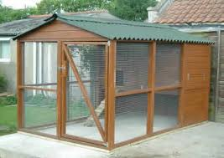
.

The below setup is ideal if you have to keep the chickens in the coop for the most part of the day, as it gives them ample room to roam around in and provides a fully enclosed shed they can sleep securely in at night. You would not want to put more than 6-8 girls in such an enclosure, any more an it begins to get too cramped and fighting may occur.
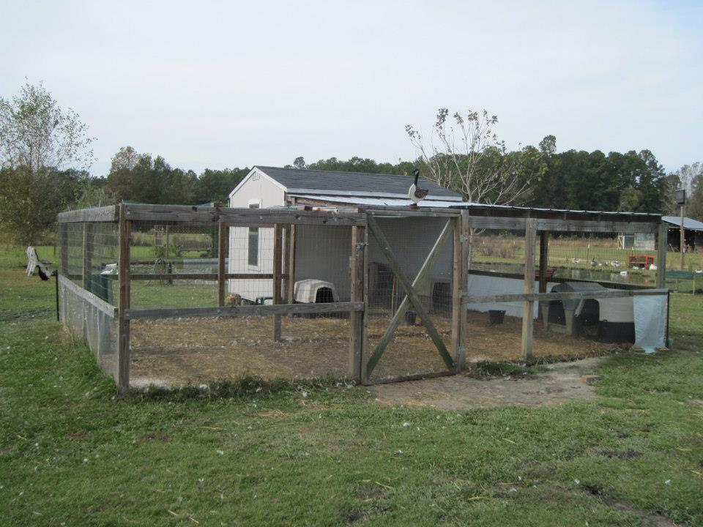

Some chickens like to perch rather than sleep on the ground or in a box, so all options should be given to them. You can use branches, or wood bought from the hardware store. Note that it needs to be a reasonable size so they can grasp it comfortably with their feet, the recommendation is a diameter of about 5cms (or 2 inches).

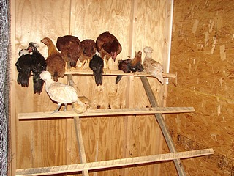
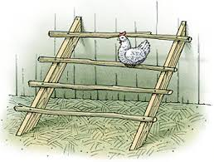

Nesting boxes can serve two purposes – for laying eggs in and for sleeping in, and can be made out of pretty much anything you can find, or make them from scratch with building materials.

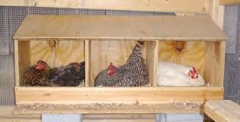

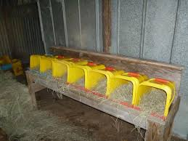

BEDDING
We recommend straw only as shavings and sawdust can cause respiratory problems.
Please ensure that when straw is stored, that it is kept dry. Wet bedding is not nice for chickens, plus it can possibly build up mould which again is unhealthy for chickens and a potential killer. Tarps are handy to use, you can lift the bales off the flooring by using planks of wood or pallets or similar. You can also get bale bags from shops like Pet Stock, that have handles on the side for ease of carrying.
Bedding should be cleaned daily and should be dry. No one likes to sleep in their own waste or the stench of it, and by cleaning daily you will avoid attracting flies, maggots and bacterial build up. Obviously straw will need to be replenished as it’s removed, leaving a nice soft and warm bed for the chickens to sleep in. When it is hot then not as much straw is necessary.
It is recommended that bedding be sprayed with lice/mite treatment every few months (if the straw is still in good condition and cleaned daily) as lice/mites can live in the straw. If you have any wooden perches etc in their housing, they need to be sprayed too as they can live in that as well.
Bedding should be completely replaced and the area given a good clean/disinfecting on a regular basis. How regularly this occurs is of course is up to your judgement but is dependent on how dirty the straw/house looks. If cleaned daily then this could be delayed a bit longer as opposed to a house that isn’t cleaned as often. A big cleanout every 4-6 months should suffice, but again, this is something you will need to judge.

LICE AND WORMING TREATMENT
We recommend Avian Insect Liquidator, which comes in a concentrate or ready to use bottle. Using the liquid form of lice/mite treatment kills them straight away. Do not use a dust powder, they are not anywhere near as effective and chickens will preen it off themselves. Dr Petrovic (listed below in the vet section) also confirmed this.
However, any liquid spray is preferable to dust powder, regardless of the brand.

What to look for when examining the chicken for lice and mites
We have already treated your chickens for lice and mites, but this needs to be done on a regular basis (every 6 weeks). Lice and mites are very small and hard to see, and just because you can’t see them does not mean they are there.
Lice like to live around the cloaca area, under the wings and around the neck of the chicken. They generally lay their eggs on the base of the feathers around the cloaca, and you can see the build up fairly easily. We generally trim the feathers to rid them of the eggs.
When spraying the treatment onto the girls, the areas you should focus on are:
- around their bottom (avoid the cloaca)
- their chest area
- their back
- around the back of the neck
- under their wings
Be sure to keep the mist away from their eyes, and fan the feathers so you can spray onto the skin as much as possible.
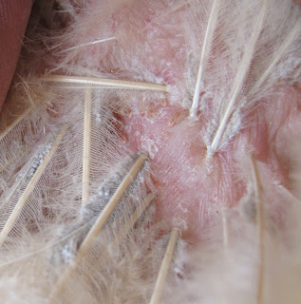

Lice and eggs around feather base
The information below was taken from http://www.backyardpoultrymag.com/laura_e_john/ and gives you an indication of what level of infestation can occur and why treatment should be regularly given.
Infestation levels can be estimated by blowing on the bird’s feathers and counting the mites that are immediately seen. The following index can be used to estimate mite infestation levels:
- 5 mites counted = Bird may be carrying from 100 to 300 mites
- 6 mites counted = Bird may be carrying from 300 to 1,000 mites (light infestation)
- 7 mites counted = Bird may be carrying from 1,000 to 3,000 mites – small clumps of mites seen on skin and feathers (moderate infestation)
- 8 mites counted = Bird may be carrying from 3,000 to 10,000 mites – accumulation of mites on skin and feathers (moderate to heavy infestation)
- 9 mites counted = Bird may be carrying 10,000 to 32,000 or more mites – numerous large clumps of mites seen on skin and feathers; skin pocketed with scabs (heavy infestation)

Lice treatment
Avian Insect Liquidator
Controls mites and lice on ornamental birds and their environment. Protects for up to 6 weeks.
Recommended for: Use on mites, lice, flies, spiders, ants or any situation where external parasites are a problem, including nest boxes, flights, perches, aviary floors, indoor cages and for direct application to the bird.
Key features: Instant control of pests on contact with additional 6 week residual protection against reinfestation. Penetrates into the plumage of birds to kill mites and lice under the feathers and on the skin. 100% safe for use on all birds.
Size: Concentrate: Available in 100mL and 500mL. Ready to use: Available in 100mL and 500mL.
http://vetafarm.com.au/product/avian-insect-liquidator-ail/
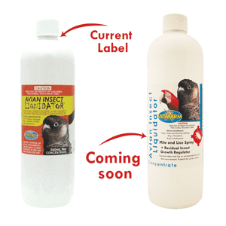

Natural lice/mite deterrents
We have read that dried garlic leaves and lavender are great natural deterrents for lice and mites. Just place some garlic leaves or lavender sprigs in their bedding where they sleep.

Worm treatment
Worming treatments come in liquid or tablet form. Liquid form gets put in the chicken’s water and is based on the assumption that all the girls have had a drink of their fair share. The other form is tablet, and although it may seem a bit daunting, is better to use as you know the hen has received her dose. The tablet goes down the back of the throat, make sure it is put down in front of the tongue, if you are unsure you can look up some videos or ask your vet to show you how. Here’s one link but it’s not that easy to see:
http://www.youtube.com/watch?v=NDFl1AIWSwI
Tablets If you are to give your chickens tablets, it is easiest to do so when they have gone to bed, as they are very quiet and you don’t have to chase them around the backyard.
We use Sykes Big L Poultry and Pig Wormer which contains the active ingredient Levamisole and controls large round worm, hair worm and caecal worm. For best results withhold drinking water for 2 hours before nightfall, replace with medicated water the next morning. Dose rate - Dilute 100mL with 2L of clean drinking water.
.
Natural remedy A natural remedy for keeping worms at bay is apple cider vinegar in their water. It assists in keeping the chickens’ immune system strong. Refer to the link for more information, but the suggested mix is 2% ACV should be added to their drinking water, in other words 20ml per litre. If they don’t like the taste using that ratio then reduce it so it’s not as strong. Do this only every few weeks.
Do not buy pasturised ACV as it will also kill the good bacteria.
http://poultrykeeper.com/health-suppliments/apple-cider-vinegar
Worming using flea treatment You can also use a flea treatment such as Advantage for Adult Cats over 4 kg (see Scaly mites section), by placing 2 drops onto the back of the chicken’s neck, every 3 months. Remember to choose a treatment that treats for both internal and external parasites.
Here is some useful information taken from the backyard poultry forum. http://forum.backyardpoultry.com/viewtopic.php?f=3&t=8010118

Worming directly involves using a tablet or measured dose of liquid and putting it straight into the beak of the bird. To do this you need to be able to hold the chicken and so if you never handle them it might be a problem. I tend to do it either at night when they have all gone to bed or in the early morning before they are up. That way I can pick them up straight out of the coop. I can hold the chicken still, and open its beak with one hand and put the tablet in the beak with the other. That's all there is to it and that way I know they have had the exact dose they need. The other difficulty with any direct dose is you need to have a vague idea of weight - you can weigh 1 bird and if they are all about the same size just work on that figure. For example my bantams are all about 1kg - the tablets I use are 1 tablet per 2kg so they each get 1/2.

I use Vetafarm Wormout tablets which you can get online or from bird supply shows. There is also Avitrol Plus which is a small tablet. I also have Moxidectin which is a liquid and to administer that I draw up 1ml, insert the syringe down their throat ( you have to know what you're doing) and then push it out into their crops. This is to avoid getting any in their airways. If that seems scary just stick to the tablets, they are straight forward.
Regardless of what wormer you use you need to repeat the process about 10 days later to ensure you kill any worms that were only eggs at the time of the original worming. If you've never wormed them before you will probably be able to see a number of dead worms in their poo in the days following the treatment. Nilverm, Big L, Avitrol Plus, Moxidectin Plus, Vetafarm Wormout, Piperazine are some brands but there are plenty out there. I recommend you get a wormer that contains Praziquantel as that is the chemical that kills tapeworm which my chickens seem prone to. Anything with 'plus' in the name tends to have praziquantel in it. Just think about what method of wormer would work for your setup, see what is available at your local vet, produce store, pet store or online if that is preferred, and follow the instructions.

Recommendations for how frequent worming should be include once a year, twice a year, 4 times a year and the 2 vets I have seen recently advised every 6 weeks, particularly in the wet, humid days we've been having recently.

Here is another website with general information about worms, keeping in mind it’s a UK site referring to different worming treatments http://poultrykeeper.com/general-chickens/worming-chickens

VACCINATIONS
There are no need for vaccinations, chickens are vaccinated as chicks.

OTHER ANIMALS WITH CHICKENS
It is not recommended to allow animals such as dogs near chickens. There have been many instances we have been told of where the usually friendly and well-mannered beloved pet dog has attacked and killed chickens. Dogs should never be left unsupervised if they are out with the chickens for whatever reason. But we stress, it is best to avoid having dogs around chickens, no matter what.

ILLNESS

Respiratory illness
Chickens can show respiratory illness and it is not uncommon for them to “catch a cold”. The most common cause is Mycoplasma. You will hear a very slight gurgling coming from their chest/throat area, they look sleepy and slow down, they can get swollen sinuses and you can see little bubbles coming out of their eyes and nostrils. This can be treated easily with an antibiotic, either in powder form that’s added to their water, or in tablet form. It is important to separate the sick girl from the rest of the flock so she doesn’t spread the illness to them, isolating them in a quiet room in the house is ideal, and it is also wise to have a separate area in your yard for this kind of purpose.
Powder form – tylan
Tablet form – doxycycline

Scaly Mites
Sometimes chickens will have scaly mites, where the mite buries itself under the scales of the chicken’s feet and legs and gives a lifted, white, dried, crusted and rough appearance, see below. This of course causes pain in the chicken and needs to be treated. Not treating the mite can lead to the chicken’s death.
Note scaly mites are transmitted by contact with infected birds, if you have some birds showing signs of this but the rest of the flock have no obvious signs, you will still need to treat them.
They can either be treated through your vet, or you can use a parasite treatment you’d use for cats (must be for Adult cats over 4kg) that covers both internal and external parasites. All they need are two drops from the tube, onto the skin on the back of their necks. You will also need to bathe the feet and legs daily to soften the skin and clean the dead bits of skin off and to help get rid of the mites. The build up of the scales is due to the mites’ faeces, and the rough look occurs over several months. Rub in a Vaseline or paraffin oil to smother the mites. This will need to be done daily for a quite a few weeks until you can see a very noticeable improvement and that the legs and feet are regaining normal appearance (they will look very smooth initially, until the scales grow back again which may take many months).
You can continue using the flea drops to keep scaly mites at bay but also to treat worms. Place two drops onto the back of their necks every 3 months. This would be much easier for some people to do than placing worming treatment into their water or giving them a tablet.
Please note the bedding and sleeping area will need to be treated for mites, clean with housing thoroughly with a disinfectant, make sure you rinse it off thoroughly as well, and spray with a mite/lice treatment.
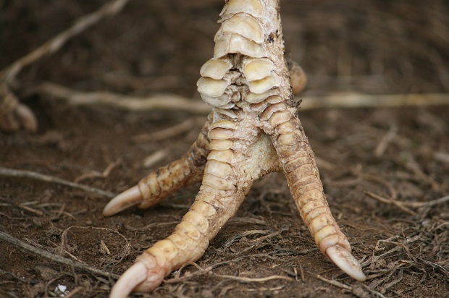
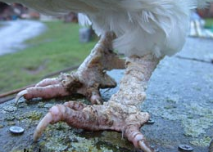

Examples of what scaly mite infestation looks like
Egg bound
This information is from the http://beautyofbirds.com/eggbinding.html and http://www.keepingchickensnewsletter.com/site/egg-bound-chicken-symptoms-and-treatment websites.
Egg binding refers to a common and potentially serious condition where a female bird is unable to pass an egg that may be stuck near the cloaca, or further inside the reproductive tract.
There are a few common reasons a hen can become egg bound - one is that the egg is just too big for the pelvis, another possibility is there is not enough calcium in the diet (calcium is required for muscle retraction), another possibility is that she might be too weak from some other condition (or too fat) which could be nutrition or illness related, and sometimes she may be dehydrated and the part which moves around the egg as it is laid is too dry and stuck to it preventing it from getting out.
Signs that you may have a chicken that is egg bound could be repeated visits to the nest and/or trying to lay an egg for hours and becoming distressed. Later on she may become lethargic and 'droopy'. If you have noticed your hen acting strangely in this way (you may even get alerted to it by one of her coop mates who has raised the alarm) you can check for egg bound by looking at, and massaging around her bottom area for an egg shaped lump.
Treatment at home if you are unable to get her to a vet straight away.
- Suspected egg binding: Keep her in a warm area. Provide supportive care (http://beautyofbirds.com/sickbirdcare.html).
- Place the bird into a steamy room, such as bathroom with shower on until the bathroom mirrors and windows steam up. Desired temperature: 85-90 degrees Fahrenheit / Humidity: 60%. Place bird on wet towel. The warmth relaxes the hen so that the vent can dilate more allowing the egg to pass.
- A warm water bath can also be of great help (shallow water, of course, you don't want to drown the hen). This relaxes her muscles and often the hen will pass the egg into the water. Make the water as warm as you would like to take a long soak in.
- Massage the muscles in that area with olive oil. In many cases, this lead to a successful passing of the egg. Note: there is a risk associated with messaging this area. It could cause the egg inside to break - which is life-threatening. Be very careful! If in doubt, it's always best to have the vet take care of it ...
- Even if the cause is not hypocalcaemia in this hen’s case it will not hurt her to have more calcium.
- Applying a personal lubricant, such as KY jelly to her vent may also be helpful.
- To reduce swelling on her vent, some breeders reported success in applying Preparation H to her vent.
- Successful Passing of the Egg: Following passing of the egg keep the hen in a warm and quiet area separate from the others, until she is out of shock and back to eating and drinking well.
- Prevention: Provide bird with high-calorie, high-calcium food to help strengthen future eggs and prevent egg binding. Recommendations for pet bird diet / nutrition.
You can also try using microlax, a medicine used to relieve constipation which comes in a small tube ready to use. Squeeze a small amount into the chicken’s cloaca.
Egg yolk peritonitis
This information is from the chickenvet.co.uk website.
There are occasionally difficulties and these birds may be experiencing an internal or blind layer problem. These terms are used to describe birds whose oviducts (egg tubes) are not functioning as they should be.
Usually the oviducts carry the yolk from the ovary to the vent over a 24 hour period. During this time the white, membranes and shell are formed around the yolk. In chickens with damage to their oviducts the egg does not form properly and the yolk is laid internally into the belly/abdomen. These yolks can be absorbed over time but in most cases the chicken lays them internally faster than they can be absorbed resulting in a build up within the abdomen. This enlarges the abdomen and causes the chicken to experience discomfort and difficulty breathing. In order to help relieve the pressure on the abdomen the chickens adopt an upright penguin-like stance.
Some factors such as coming into lay and stress can cause the odd internally laid egg. However, severe oviduct damage, can lead to permanent oviduct problems and therefore they remain internal layers for life.
This condition leads to a life of discomfort. Often the chicken will lose weight and have prominent breastbones. Deceivingly, due to the build up of egg yolk in their abdomens, they appear to be roughly a normal weight.
These birds can be:

- speyed (have the oviduct surgically removed)
- have a hormonal implant inserted by a vet to stop ovulation
- kept by a watchful and observant owner who knows the problem exists and makes veterinary contact if they suspect a brewing peritonitis
The mass of egg yolk in the abdomen can provide a rich medium for bacteria such as E. coli to thrive and cause peritonitis. These birds become dull with hot swollen abdomens and in severe cases they will develop blood poisoning and go into shock and invariably die.
Treatment often involves using antibiotics which usually helps to treat infection, however, unless you are able to stop the bird laying internally, the peritonitis will usually return.
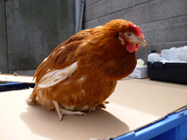

Upright stance typical of a chicken with egg yolk peritonitis
If your chicken/s end up suffering from either of these conditions then we strongly recommend you look into getting a hormone implant for them that stops them from laying eggs. This is inserted at the back of their neck and can last around 6 months, but can be more or less. It will be a huge relief for your chickens to have some reprieve from the stress of egg laying and certainly could be a life saver for girls who suffer from egg binding and egg yolk peritonitis. Please speak to your vet, if they are unfamiliar with treating chickens then please take them to a vet who is, we have listed a few vets at the end of this booklet, and Burwood Vet are happy to provide advice/guidance to vets who are inexperienced.
There are other illnesses that may appear but these seem to be the most common that need attention.
Egg problems in general
If your chicken is laying thin shelled eggs, shell less eggs, yolks only, cooked looking yolks, or any kind of egg that is not normal looking, see your vet. This is a sign she will most likely have ongoing issues and the best way to address this is to get her implanted with a hormone chip to stop her laying.
Messy bottoms
Chicken poop comes in many forms, they say there are about 9 different types! The usual one is white/black and firm, and there is a sloppy black sticky one called caecal poop. They are normal. What isn’t normal is if your chicken has really runny poop, and her bottom is wet and dirty from it. Their poop should basically projectile away from their bodies, although sometimes this doesn’t happen and that is normal.
This can be a sign of worms so treat your girls with a wormer first, if she doesn’t improve then take her to the vet.
Bumblefoot
Occasionally chickens may develop issues with their feet and can get a condition called Bumblefoot. This is a bacterial infection or abscess on the base of the foot and must be treated as it can cause death if not treated, as well as being contagious to your other chickens. It’s not something we’d really expect in your chickens, as it usually develops in heavier birds, but it’s something to be conscious of. A sign that this may be a problem is if your chicken is limping. Rough perches and wire flooring can contribute to the condition. You will see some swelling at the bottom of the foot and possibly a black scab.
To treat the chicken place her in a separate recovery area, this will allow a faster recuperation but also keep possible contamination of the other chickens at bay. She must see a vet to get some antibiotics to fight the infection. Daily soaking and cleaning the foot with salty warm water and dabbing on some betadine will assist in healing. The vet will be able to give you instructions. For information on Bumblefoot see the below link or simply search via google.
http://www.dummies.com/how-to/content/how-to-treat-chicken-foot-sores.html
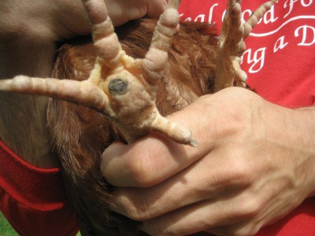

An example of bumblefoot
Sour Crop
Information taken from http://luckyhensrescuenorthwest.weebly.com/crop-help-sheet.html
Sour crop is caused when the crop doesn't empty fully overnight and as a result the food ferments within the crop causing a fungal infection.
You can Identify Sour Crop by checking the crop before the hen eats in the morning, if it is Sour Crop, the crop will be watery and squishy like a balloon. If you open the hen’s beak, a foul smell will emanate from it.
Symptoms: Quiet, sleepy and sometimes hunched hen. Large crop full of fluid that does not disappear overnight. Sometimes diarrhea. Lack of appetite. Thin if it goes unnoticed.
Treatment: Take your chicken to the vet, they will advise a course of treatment which will usually involve an anti-fungal treatment like Nilstat, which is the commercial name for Nystatin and is used to treat a condition called oral candidiasis or thrush.
Prevention: In order to avoid crop problems you should make sure that along with pellets there is an ample supply of poultry grit for the hens. The grit breaks up the food in the crop and without it the food cannot be broken down and the digested, the calcium in the grit also benefits laying hens. Long Grass should be cut down as this can compact in the crop (as can hard treats) and stodgy food such as bread and pasta should be fed sparingly as treats as these can also cause a compaction in the crop.
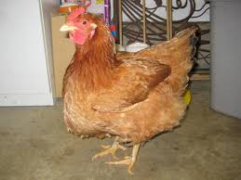
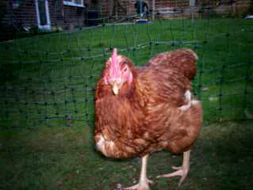

Examples of sour crop
Impacted crop
Impacted crop (crop bound) is similar in cause to Sour crop in that the crop does not empty overnight but in the morning it will feel hard and swollen, like a golf ball.
In both cases the hen is likely to seem lethargic, will lose weight and may make strange head movements due to the discomfort of the crop.
Treatment: If you suspect your hen has an impacted crop, start treatment in the morning by dropping a small amount of olive oil or liquid paraffin (2-3ml) mixed with water into the hen's mouth making sure you insert the liquid past the hole at the base of her tongue which leads to her lungs, and then gently massage the crop in a downward motion to help break up the compaction and repeat this in the afternoon.
Keep the hen separate to ensure she has passed any blockage.
Make sure your hen has access to fresh water at all times with ACV added. When you feel your hen is ready to eat, start by feeding soft food such as layer mash and add water to soften the food. It may take a couple of days to break up the compaction, but if it persists for 3 days we advise you see a vet.

BEAKS
Most chickens will have had their beaks trimmed by the egg laying industry, as this is their solution to reducing injuries chickens cause to each other when they fight due to the cramped conditions. Sometimes you will see severe cases of beak trimming where they have cut the beak extremely short. In these cases you will need to make it as easy as possible for her to drink and eat, by providing deep dishes of water and food so she can eat more comfortably. We also find that by soaking some pellets and seeds in a deeper dish allows them to scoop up food more easily. Some severely de-beaked chickens will need extra attention to make sure they are coping well enough with eating. They will not be able to pick at whole leaves of vegetables like spinach and kale, nor eat whole corn on the cob, and they will need your help by cutting the greens into very small pieces with scissors (or use a food processor) and slicing the kernels off the corn for them.
Sometimes you will see the beaks are misshapen, or quite long and this is due to the chickens not having access to yards and pecking at the hard ground. Over time and with access to free ranging the yard, the beak should wear down and form a better shape. If it doesn’t then you should take her for a visit to the vet.
You may also see growths around the sides of the beaks too, which looks similar to thin fingernails, these are not usually a problem and may come off in time with free ranging. If it doesn’t resolve itself then take your chicken to vet so they can trim it down.
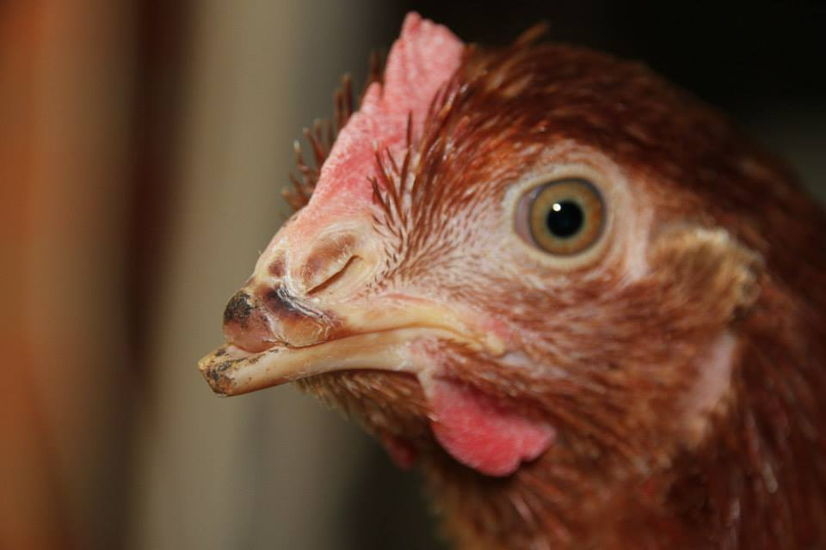
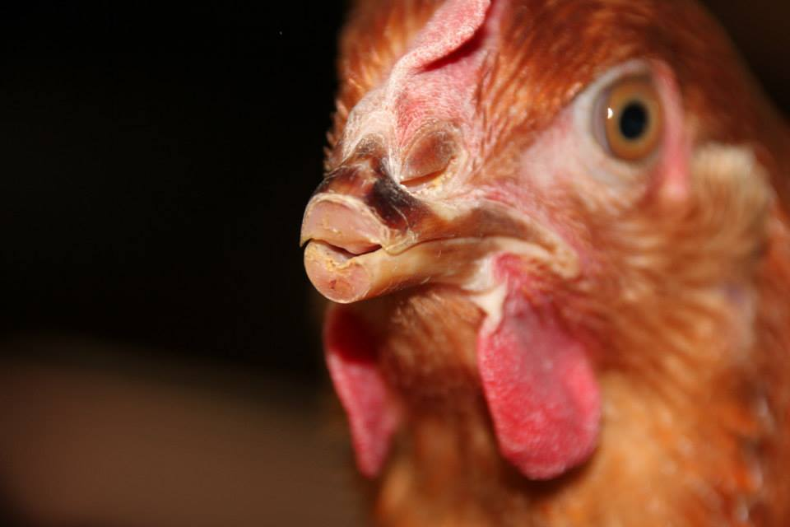

An example of beak trimming gone horribly
wrong. These girls were amongst a group re-homed by us.

MOULTING
Chickens lose their feathers each year and this usually begins around February and finishes around June. This is normal and you can help the process by feeding your girls extra protein and vitamins to assist in the re-growth of their feathers. Here’s some interesting information taken from the backyard poultry website http://forum.backyardpoultry.com/viewtopic.php?f=5&t=1370&start=0

Moulting
This is a physiological phenomenon, which consists of the shedding of existing feathers, followed by replacement with new feather growth. It is usually accompanied by a reduction in egg production or even a complete halt.
Natural moulting
Prior to obtaining adult plumage, fowls at several stages during their life undergo a number of moults where the old feathers are replaced by new feathering.
First moult - when down is replaced by the first juvenile plumage occurring at 6-8 days and ending at 4 weeks.
Second moult - when the first juvenile plumage is replaced by the second juvenile plumage. This occurs over a number of weeks starting between 7 and 12 weeks of age.
Third moult - occurs in the hen at 16 to 18 months. This is the 'moult' of most importance for producers.
In the laying hen, natural moulting occurs at the time of year when the days are getting shorter, ie. from January to June. Hormones secreted by the thyroid gland determine the course of the moult. The use of artificial lighting to maintain a constant daylength can be used to avoid this natural moult. This occurs principally by altering the daylength 'hormone-clock' within the bird.
Moult characteristics
Shedding is first observed in the feathers of the head and neck, then those of the breast and finally of tail and wings. Moults can be partial (occurring on particular body parts) or complete. The extent of moulting depends upon the breed and the individual bird. The length of the moult is variable, poor layers reconstitute their plumage in 6-8 weeks while good layers following a pause in laying can replace their feathers in 2-4 weeks.
Physiologically, the stop in egg production allows more dietary protein to become available for production of feathers which are primarily proteins themselves. Oestrogen, a hormone released during egg production, retards feather formation. Cessation of lay reduces oestrogen levels so that feather formation is enhanced.
Stress
A number of factors act as stressors which can contribute to a cessation of egg production and the onset of a moult. Generally a lack of food or water is the most frequent stress causing feather loss. Poorly balanced diets or mouldy feed can also bring on moulting. Lack of cool, clean water even for a short time can cause birds to moult. To minimise this an emergency backup water-supply is advisable. Feather loss can also be caused by chilling, overheating and poor ventilation. A good housing environment will eliminate temperature extremes and still provide good ventilation for the birds. Ill-health either from injury, disease, parasitism or bullying may also contribute to moulting. Medication and regular monitoring of birds will minimise stress and reduce further feather loss.

BROODING
Sometimes chickens will sit on eggs for long periods, anything from a few weeks to 6 weeks or more and only leave them a few times a day to eat and drink. The main concern with this is if it’s during hot weather, as they may get very hot and not be drinking as much water as they need to. They should be monitored closely and given close access to food and water during this time, and made sure they are not overheating. If it’s hot, place some cool packs around her.

WHAT YOU CAN DO WITH THEIR EGGS
You can actually feed the girls back their eggs and can give it to them raw or cooked. The eggs can be boiled and a masher used to mash the egg along with the shell. The shell is very good for them as it contains calcium. Don’t give them too many though, maybe once or twice a week. If giving them raw eggs, keep the shells and grind them up into a powder to give back to them.

FIRST AID AND FIRST AID KIT
Sometimes chickens will cut themselves, usually on their feet. If you see there is a cut or bleeding, you can bathe the wound using salty warm water (1 teaspoon per cup of warm water), dry the wound with a clean cloth and then dab some betadine on it. If it is a bad cut then confine the chicken in a separate room in the house, or a pet pen, for a day or 2. This will ensure the wound doesn’t get covered in dirt and gives it time to heal, as we know, chickens love to scratch around the dirt all day.
It is handy to have some items on hand such as:
- nail clippers (the type for cats and dogs will do the job)
- betadine
- saline solution (or salty warm water will do)
- tweezers
- scissors
- bandages
- torch
- some medications like metacam (for pain relief) and an antibiotic like baytril or tylan (you will need to see your vet with your chicken for these to be dispensed). Antibiotics will only be dispensed initially if your chickens shows signs of an infection
- Rescue Remedy – is a liquid you can use to help calm down scared and flighty chickens who may be having some trouble settling into their new home or getting comfortable with their fellow chickens
- Microlax – for flushing out the cloaca if your chicken has a soft shelled egg stuck inside her
- Kwik Stop Styptic Powder. Quickly stops bleeding caused by clipping nails, minor cuts etc.

WHEN CHICKENS GET WET
Chickens can cope with getting a little bit wet, but if they get pretty soaked, then this can give them a chill. You should dry them off thoroughly and observe them. Some girls can get really knocked around by a soaking and go quiet and not be their usual selves. If you notice this, bring them inside and warm them up by placing them on a cosy blanket or towel, and placing a covered hot water bottle or heat pack beside them. If they don’t’ perk up by the next day, take them to the vet.

WHEN CHICKENS GET HOT
Chickens can easily overheat in hot weather, you will see them panting, holding their wings away from their body and unable to walk around as usual. They need to be cooled down as fast as possible, place them into a tub of cool water (not cold though as it may cause shock) so their temperature can drop, and you can also put some cool water around their face and on their combs and wattles. You can also place some cool water under their wings. Keep them out of the heat, you may need to take them inside in an airconditioned room until the hot weather subsides, continuous hot days can be relentless for chickens and can cause death.
See the link from NSW Hen Rescue for more information on how to help your chickens out during hot weather http://www.henrescue.org/#!keep-hens-safe-in-heat/c13os

TRANSPORTING CHICKENS
To transport chickens it is preferable to have carriers as you would for cats, lay down some newspaper and straw or a towel for them. If you are travelling for a few hours make sure you provide them with water.
If you don’t have carriers, you can use boxes but ensure there are adequate holes cut out so they can get fresh air. We generally cut a small strip on each side so they can also peer out of the box.
If transporting them on warm days in the car, make sure they can also get some air conditioning as they will heat up quickly.

THE MAIN ISSUES FACED WHEN PROVIDING A HOME FOR CHICKENS
1. Locking them up at bedtime
It is imperative that chickens are locked up every single night as soon as they go to bed. It is even more important to do this in areas that are still quite rural/bush. In these settings, they may need to be put away to bed before they are ready to head off themselves. We have seen that forgetting to do this for just one night has led to girls losing their lives. It is heartbreaking when this happens when it is completely avoidable. These girls have been saved from death on a factory farm only for the wonderful opportunity of freedom and happiness to be stolen from them due to carelessness. They are completely dependent on us to make sure they are safe and protected.
2. Secure housing
Foxes will work their way around any weakness they can find in your chickens' housing. Any gaps they can dig under or push through will be found. Housing needs to be absolutely water tight, with fox proof wiring used for the entire enclosure, including flooring and roofing. Of course some housing has concrete or brick flooring which is secure. Some people use sheds on concrete or brick flooring which is also secure. Regardless, where they sleep has to be completely secure so foxes can't work their way in. Foxes will kill a whole flock if given a chance, they are not doing this for "fun" but rather to stockpile the chickens for eating at a later stage, however they are usually caught in the process of killing all the chickens.
Be aware that foxes are a danger to chickens even in built up, suburban areas.
Please remember that foxes are an introduced species, just like chickens are, and they are just trying to survive relying on their instincts and opportunity. If you don’t give them the opportunity to kill your chickens then there will not be any issues.
3. Signs of illness
Chickens can succumb to illness very quickly, however if spotted early on and with immediate action, can also recover quickly. If a chicken is seen to be "off colour" and not their usual self, then something is going on. They might be quiet and sleepy when normally they would be active and exploring the garden, or a bit fluffed up. Their wings may also droop down. It is important to move quickly if this behaviour is seen. Move them somewhere quiet and warm if it's during cold weather, put them in something like in a carrier in a spare room of the house. Give them a hot water bottle (wrapped up so the heat is not directly on them) and some chopped up favourite food and water. If she won’t eat on her own then you will need to hand feed her, or syringe a watery mushy food like the vegie mash into her mouth. If this hasn't helped her by the next day then she must visit the vet. They may need something like an antibiotic to help them along if they are a bit under the weather, or it could be something to do with their reproductive system (egg bound, egg yolk peritonitis) and something that definitely needs veterinary attention.
Do not let your chicken wallow for days looking unwell. If she hasn't improved at all by day two, you can assume that she won't get better on her own and will need help, she will need to visit a vet asap.
4. Hot weather
If it is hot and is has been for a number of consecutive days, this can wear down your girls and kill them. We've heard incidents of chickens dying during hot weather but with some effort, this can be avoided. Put out lots of trays of water for them, to keep it nice and cool you can place ice blocks in there. You can leave a sprinkler on for them, just on a gentle setting, wet areas provide a cool haven for chickens to rest in. At night you can leave ice blocks in their bedding, wrapped in a light towel. Plastic water bottles that would normally be thrown out do the trick nicely. If it is too hot and some girls are struggling, bring them inside your home so they can enjoy the fan or air conditioning. You can use a pet pen to keep them in, or put them in an area that's normally cooler like the bathroom or laundry.
5. Cold weather
If it's cold make sure the girls have lots of bedding to snuggle into, straw is great for this. Like humans, chickens are different and some will feel the cold more than others. Place little boxes/crates in their bedroom so they can choose to get more protection if they want. Make sure there are no cold draughts, these can also cause illness and kill chickens.

VETS
There are a few vets we know of who are very good with chickens:
Bird and Exotic Animal Clinic Williamstown
19 Ponting St Williamstown 0406522013 www.beacvet.com
BURWOOD BIRD AND ANIMAL HOSPITAL
http://www.birdclinic.net/
Ph: (03) 9808 9011 Address: 128 Highbury Road, Burwood, Victoria, 3125
Dr Patricia Macwhirter - Pat started Highbury Veterinary Clinic in 1981 and has continued at the clinic since. In 2003 she went into partnership with Dr Philip Sacks.
Dr Phillip Sacks - Phil joined the clinic in 2002 and became a partner in 2003. Phil's Previous veterinary employment includes teaching at veterinary universities in South Africa and Melbourne, Gribbles veterinary laboratory Melbourne, Johannesburg Zoo, Army treating guard dogs and Horses, and his own small animal Hospital.
VetCall Footscray
www.vetcall.net.au
0415773670
1/569 Barkly St Footscray

Dr. Gloria Perkovic BVSc (Hons)
“I graduated from the University of Melbourne in 2004 with First Class Honours in Veterinary Science. After my studies, I spent my first 3 years working in a busy small animal practice in the western suburbs of Melbourne. Following this, I was lucky enough to spend a year at the University of Sydney teaching students and completing a Graduate Certificate in Veterinary Clinical Studies, while working in their general practice clinic. After returning to small animal practice in Melbourne, I continued to develop my interests in animal behaviour, pocket pets, internal medicine and diagnostic imaging. I currently share my home with 2 cats, 2 Staffordshire Bull Terriers, 2 galahs, 4 rabbits, 1 large fish and a husband.”

MELBOURNE BIRD VET

http://www.melbournebirdvet.com/
Phone: 03 9764 9000 Address: 1 George St (corner of George St and Stud Rd) Scoresby VIC 3179
Opening Hours
Monday 8.30am - 5.30pm
Tuesday 8.30am - 5.30pm
Wednesday 8.30am - 7.30pm
Thursday 8.30am - 5.30pm
Friday 8.30am-5.30pm
Saturday 9.00am - 12.00midday
Sunday CLOSED
The Melbourne Bird Veterinary Clinic is located in Scoresby, a south eastern suburb of Melbourne and is operated by avian vet Dr. Colin Walker. Colin works with a second veterinarian, Dr. Corrie Pinkster and 4 nurses Laura Van Dinther, Marcia McDonald, Kerrie Wilkinson and Ian Osmand. Being specifically designed for birds means that this clinic is able to incorporate features that are especially bird friendly, many of which are not found in general practices. There are two hospital areas. One looks out into a small private garden and contains 20 individual thermostatically controlled heated cages. A range of perches and bowls are available together with a fridge holding food catering for the different species presented. Some cages are adapted so that supplemental oxygen or vapourised medicines can be given. The second hospital area acts as a quarantine to hold birds with known or suspected infectious disease. It also contains heated cages and is fully tiled to allow for easy disinfection. A separate locked store holds the medications used in avian practice. Many of these are not routinely held by general practices but need to be on hand here.

OTHER RESOURCES
NSW Hen Rescue http://www.henrescue.org/
Animals Australia - Tips on adopting a rescue hen http://www.animalsaustralia.org/features/adopt-a-battery-hen.php
The Battery Hen Adoption Project - http://www.homesforhens.net/
http://www.humanesociety.org/animals/chickens/tips/adopting_chickens.html
http://www.backyardchickens.com/

YOUR MELBOURNE CHICKEN RESCUE TEAM
Please feel free to contact us if you have any questions or concerns or just want to talk about your chickens. We want only the best for them in their new home so are happy to be available for you to contact us.
Liz Dealey – Mobile 0438829238

REFERENCES
There is an array of materials available on the internet, just search via google for the topic of interest.

